**KERAS DOCUMENTATION**

**DEEP LEARNING FOR HUMANS**

Keras is an open-source neural network library (API) written in Python and integrated in TensorFlow.

Users can build neural networks by assembling building blocks such as layers, optimizers, and activation functions.

Focuses on fast implementation.

Previous Backend engines: (1) TensorFlow, (2) Theano, (3) CNTK

Ex: CNN, RNN

1. SEQUENTIAL MODEL

Data format required -> x (numpy array, tensorflow tensor, dict mapping, tf.data dataset, keras generator) and y (same as x)

(I) KerasNLP is a natural language processing library that supports users through their entire development cycle.

EX: sentiment analysis example at six levels of complexity:

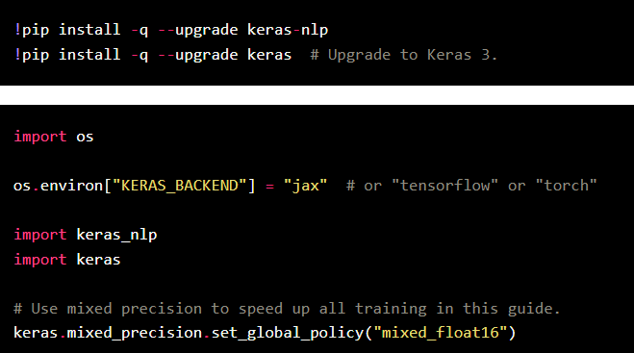

**Tokenizer**: keras_nlp.models.XXTokenizer

* **What it does**: Converts strings to sequences of token ids.

**Preprocessor**: keras_nlp.models.XXPreprocessor

* **What it does**: Converts strings to a dictionary of preprocessed tensors consumed by the backbone, starting with tokenization.

**Backbone**: keras_nlp.models.XXBackbone

* **What it does**: Converts preprocessed tensors to dense features.

**Task**: e.g., keras_nlp.models.XXClassifier

* **What it does**: Converts strings to task-specific output (e.g., classification probabilities).

XX Architecture: BERT

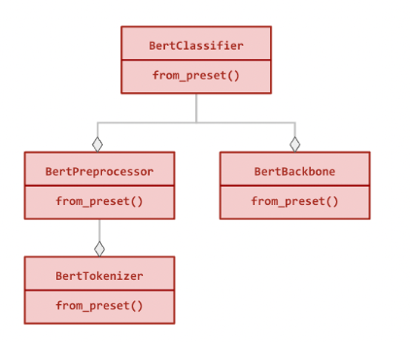

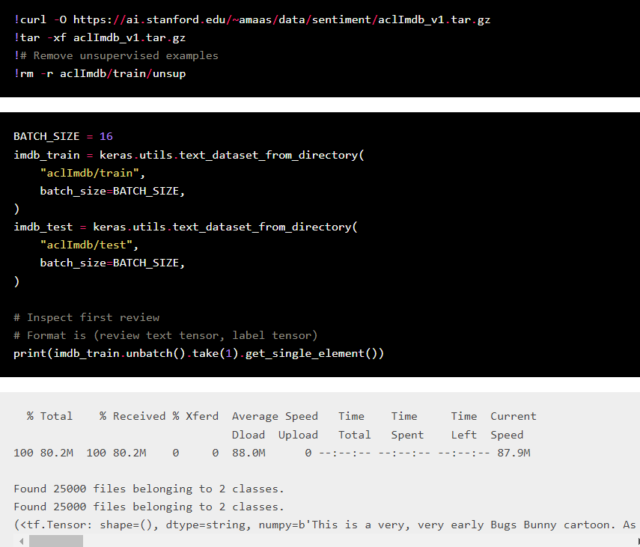

1. Inference with a pretrained classifier

A **task** is a [keras.Model](https://keras.io/api/models/model#model-class) consisting of a (pretrained) **backbone** model and task-specific layers.

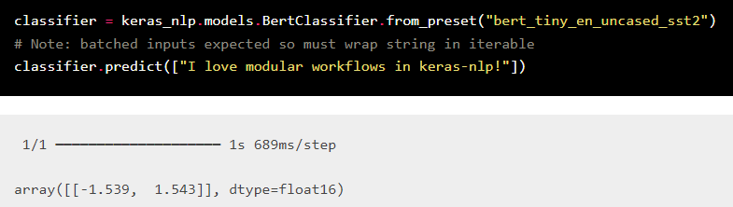

1. Fine tuning a pretrained backbone
2. Fine tuning with user-controlled preprocessing
3. Fine tuning a custom model
4. Pretraining a backbone model
5. Build and train your own transformer from scratch